**Lucy Mae U. Dalisay**

**ACT2 ACTIVITY 3**

* 1. **Create - signup using your personal information**

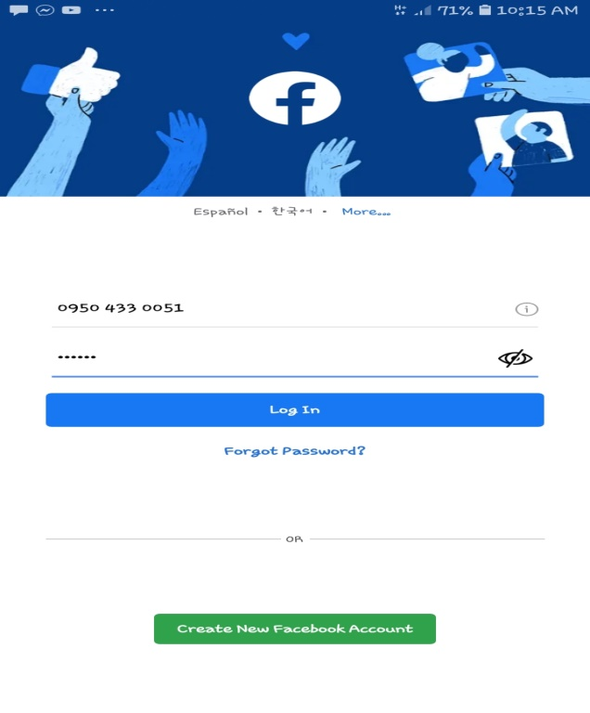

* 1. **Retrieve – search any information to the website**



* 1. **Update – update your personal information**

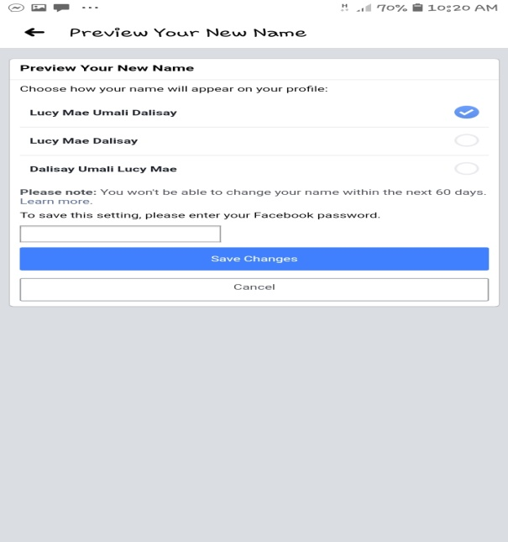

* 1. **Delete or deactivate your account**

